
Erasmus
School of
Economics
Erasmus University Rotterdam
Statistics for Data Science
Lecture 1
Dennis Fok (Econometric Institute)
September – October, 2024

Who am I
Dennis Fok
- PhD in Econometrics
- Professor of Econometrics and Data Science
- Director of Econometric Institute, Erasmus School of Economics
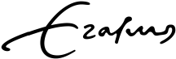
- Research interests:
Slide 2 of 30
Modeling individual behavior
Marketing models
Panel data models
Simulation-based estimation methods
High-dimensional data
- Publications:
Marketing (Marketing Science, Journal of Marketing Research, International Journal of Research in Marketing)
Econometrics (Journal of Econometrics, Journal of Applied Econometrics)

Course setup

Background of this course
Statistics:
- Most scary course –or– exiting and fun?

- Basis for many courses to follow!
Slide 3 of 30
Goals:
- (Re-)introduce statistics
- Apply everything in Python (or R)
- Not just know how to do things: also understand why!
- Critical thinking!

Setup of course
People involved
- Me!
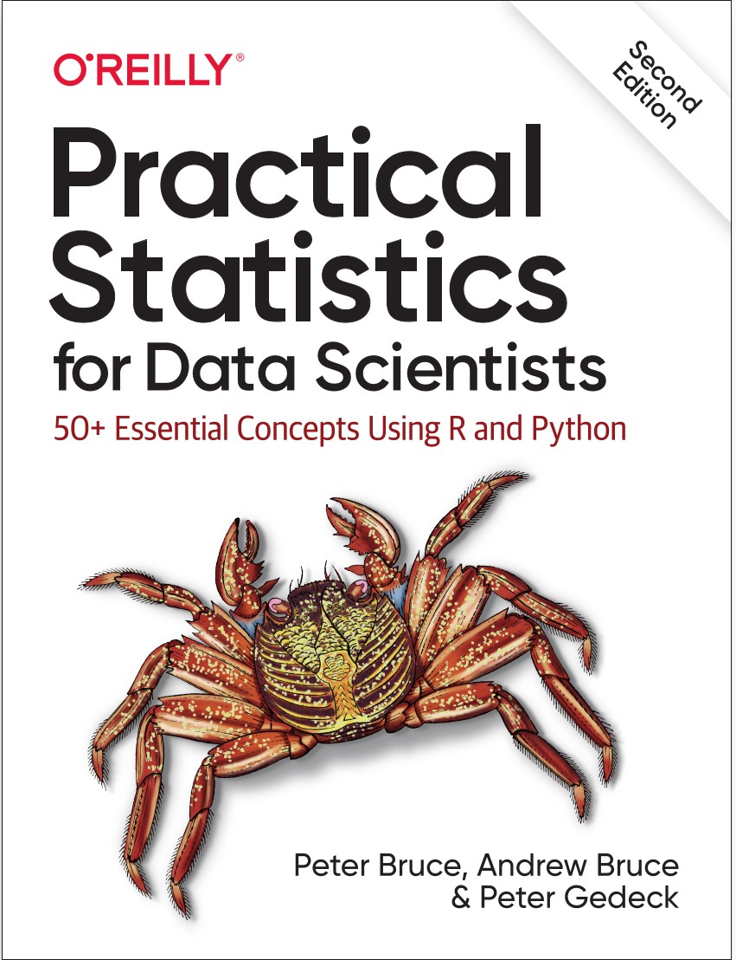
- + (technical) assistant
Material
- Handouts of slides (most important)
- Book: Bruce, Bruce, and Gedeck, “Practical Statistics for Data Scientists” (we do chapters 1 – 5)
- Additional exercises

Study advice
Steps to take:
- Preparation: read book
- Lectures

Theory In-class practice 3 After lecture:
Slide 5 of 30
Reread book (try out code examples in book)
Practice
▶ Weekly assignment
▶ Apply methods in own work environment!
- “Final” assignment is to be submitted in parts
- Questions and discussions
During class
Through Discussions on Canvas

Outline of course
- Basics of statistics and inference

- Distributions, descriptive statistics and hypothesis testing
Slide 6 of 30
- Testing for differences
- Linear regression model
- Diagnostics for multiple regression + model selection
- Generalized linear models (logistical regression)
- Bayesian statistics

Statistics

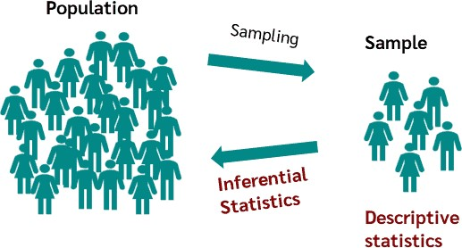
Goal of statistics
Goals:
1
Summarize
properties of data
2
Make statements on (differences across) datasets
→
Statistical
hypothesis testing
3
Estimate
properties of (assumed) data generating
Inferential statistics
Descriptive statistics
process

Inference/Inferential statistics

Usually statements on the population are the target!
Slide 8 of 30
Two important things to keep in mind:
- How good are these statements?
- Estimation uncertainty will always be present
- All methods have associated assumptions (also ML/AI methods)!
Properties of methods derived under these assumptions What if assumptions are not correct?


Some key concepts in statistics
- Data and variables
- Samples and population
- Variation and uncertainty
- Models

Key concept 1: Data
Key starting point is always: data or dataset → collection of observed variables or features
Classification of data/variables
- Role in the analysis
Dependent/Response/Outcome variable
Independent/Explanatory variable
- Measurement type
Numeric
▶ Continuous (eg. temperature)
▶ Discrete (eg. a count)
Categorical (aka: factor with levels)
▶ Binary (eg. yes/no)
▶ Nominal (no ordering: eg. color)
▶ Ordinal (with ordering: eg. disagree/neutral/agree)
Notes:
- No clear dependent variable → Exploratory statistics
- Measurement type (dependent) variable → Determines type of statistical analysis
- In R/Python: data type may determine “actions” by functions


Data sets
Terminology
- Data frame: DataFrame objects → Data like a spreadsheet
→ Structured, rectangular data
- Other data shapes: possible, but more advanced material

Key concept 2: samples and population
- Source of data
Experimental

Observational
Beware of
selective sampling
/
sampling bias
Question
How (not) to get random sample for political survey?
- Independent observations?
Repeated observations?
Hierarchical clustering? (eg. Children within a Class within a School)
- Random sample from population?
What is the population of interest?
What effects to control for?


Examples of non-random samples
- Survey on “random” people at the local market
- Response to a (e)mail/or online survey (response rate matters)
- ...
→ Compare “population” to “sample” to spot (potentially big) problems

Key concept 3: Variation and uncertainty
- Variation across samples is always expected measurement error different respondents random variation
...

→ When is variation larger than expected?
- Comparing (assumed) truth (=unobserved) versus measurement/estimation (=observed)
Expectations vs. (sample) means
- Statistical concept: significance
A difference (assumed truth − observed) is significant: → Size of found difference is unlikely under the assumed truth Not significant:
→ The found difference is not larger than what can be expected by chance alone Not significant does not mean no true difference! (and other way around?)

Key concept 4: Models
Statistical/Econometric models:

- Set of assumptions made about the data generating process
- Allow for description and prediction (and sometimes prescription)
- Important for all statistical procedures (even for “just testing”) • “All models are wrong, but some are useful” (Box & Draper, 1987)
- Know which assumptions are crucial!
- Model choice and testing of assumptions are important
- How to fix things?

Models in Python (sneak preview)
Many models are available in Python packages (eg in statsmodels), examples:
- Linear model m = smf.ols(..)
- Generalized linear model m = smf.glm(..)
- Linear mixed effects m = smf.mixedlm(..)
- etc.

Most models allow for a large range of functions/results
- r = m.fit(): fit the model to data and get result named r
- r.summary(): print summary
- r.predict(): give fitted values
- r.params: give coefficients
- sm.stats.anova lm(r): analysis of variance of fitted model
- etc
(after import statsmodels.api as sm and import statsmodels.formula.api as smf)

Organization of (statistical) analysis in Python
Steps to take:
- Import data (using pandas DataFrame: import pandas as pd)
Create a data frame directly: data = pd.DataFrame(..) Load from file, eg. data = pd.read csv("file.csv")

- Select and transform data (if necessary)
- Explore data (spot & fix errors)


data.plot(title="Title text", ..) data.describe()
- Perform statistical calculations
- Present results
Organize all of this in a script, such that the results can be replicated! → See programming course for more info

In-class assignment


Assignment
Slide 18 of 30
- See the file Day-1-AssignmentPython.pdf on canvas.
- Do exercise 1.1
Descriptive statistics

Explore data
Use descriptive statistics to understand your data Graphical:
- various plots: dataname.plot.scatter(..), for example dataname.plot.scatter(’xvar’, ’yvar’)
- histograms: dataname.seriesname.plot.hist()

- density: dataname.seriesname.plot.density()
- boxplots: dataname.boxplot(’varname’) where dataname refers to a dataframe and seriesname to a variable within the data)
Things to look for
- Degree of variation in variables
- Shape of distributions
- Signs of relations between variables (eg. correlation)
- Strange observations: Outliers!

Summary statistics
- Graphical summaries of data are useful
- Numerical summaries → basis for further analysis
Consider n observations on a variable: X₁,X₂,...,X_{n}
Measures of location/central tendency

- Mode (dataname.seriesname.mode()): most frequently observed value
- Mean (.mean() or np.mean(..) from import numpy as np)
(note dataname.seriesname should come before the . or instead of the ..)
X₁ + X₂ + ... + X_{n} 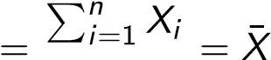
n n
- Median=50%quantile (.median()): 50% of observations is smaller
(median is much less sensitive to outliers than mean)

Measures of variation

Possible measures of variation
- Range (max-min): use .min() and .max()
- Inter-quantile range

75% quantile – 25% quantile or 3rd quartile – 1st quartile)
.quantile(0.75) - .quantile(0.25)
Also useful to detect outliers
→ Common definition of outlier: obs. more than 1.5×IQR below 1st or above 3rd quartile

Putting some things together: Boxplots
Q
1
Q
2
=
median
Q
3
IQR
1
.
5
·
IQR
1
.
5
·
IQR
Potential outliers
Largest “non-outlier”
Smallest “non-outlier”


Other measures of variation
- Mean deviation from mean? → will always be zero
- Mean absolute deviation from mean?
Very useful (robust to outliers) but
Absolute values are mathematically difficult
→ Use mean squared deviation from mean

Mean squared deviation & Degrees of freedom
The mean squared deviation is a crucial tool in statistics! Given a sample X₁,...,X_{n}. Define sum of squares = ^{P}_{i}(X_{i} − X¯)²
Important detail: how to define “mean”?
- Naive definition: sum over all i (all observations) and divide by n
- However: we used the data to calculate X¯!

- Here we know that ^{P}_{i}(X_{i} − X¯) = 0
→ We “loose” the information of one observation, degrees of freedom becomes n − 1 • Estimated variance of X (.var())
n 1
s2 = X(X_{i} − X¯)2 n − 1
i=1
- In general: degrees of freedom = no. obs − no. estimated parameters
√

- Standard deviation = Variance ( .std())

In-class assignment


Assignment
- See the file Day-1-AssignmentPython.pdf on canvas.
- Do exercise 1.2

Estimation uncertainty
n
Sample mean 1 ^{X}X_{i} and sample variance 1 ^{X}(X_{i} − X¯)² are both estimates! n n − 1 i i=1

Therefore:
- Different sample → different findings
- There is estimation uncertainty
Estimates of what?
→ Corresponding population concepts (remember the concept inferential statistics)
- Expected value: E[X]
- (Population) variance: Var[X] = E[(X − E[X])²]

Higher order moments
Until now:
- Central tendency (eg. mean)
- Measures of variation (eg. variance)

Moments of a random variable X
- First moment: E[X] = µ
- Second (central) moment: E[(X − µ)²] = Var[X] = σ²
- Third (standardized) moment: E[ 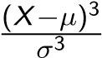] = skewness
- Fourth (standardized) moment: E[ 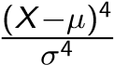] = kurtosis
→ Can estimate all of these using data
.skew() or .kurtosis()
(do check exact definition of what is calculated!)

Moments for normal distribution
If X ∼ N(µ,σ²)
- mean=E[X] = µ
→ location
- variance=E[(X − µ)²] = σ²
→ spread/variation

- skewness=E[ 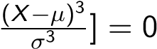→ skewed or symmetric?
- kurtosis= E[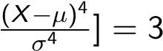
→ “peakedness”
Notes
- Often we look at excess kurtosis = kurtosis - 3
- Can test moments against values for normal distribution
(more in later lectures)

Overview of descriptive statistics
Getting a quick overview
- dataframename.describe() from pandas package
- Various packages will give you options for descriptive statistics
- If you do not have a package yet:
Install it first (see programming course). This is needed only once.
Next load it with import packagename (in each session where you use it)

Abbreviate the package name (for later use): use eg import pandas as pd instead
Also possible: bivariate (or multivariate) descriptives
- scatter plot
- conditional boxplot
- correlation
- contingency table/cross table
- ...

Assignment

Before next time
Assignment for next week
- Read
Chapter 1 (this week’s material)
Chapter 2 (next week)

- Try some examples in the book yourself (see here for data and code)
Slide 30 of 30
- Finish today’s assignments (1.1 - 1.4)
- Continue to practice using own data (or the housing data)
Create simple plots
Calculate summary statistics
Inspect distributions of some variables
(also consider transformations of variables) Visualize relations between variables
- Optional: Exercise 2 (Volkswagen prices)

